**Planning Poker- 9 Steps to Project Estimation**

*Posted On May 19, 2019*

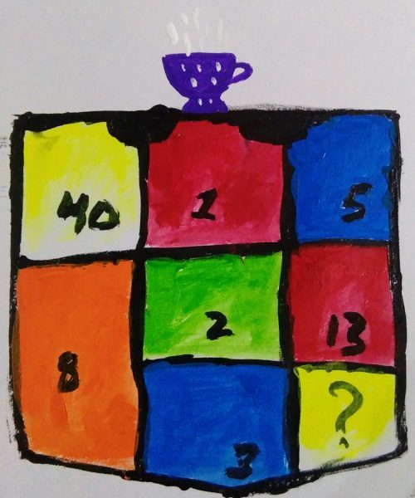

Poker word has come from popular card game being played in almost every corner of the world.

The game which is also called as ‘Poque’, a french game similar to poker was played around the region and seems to have originated there. Poker planning also called as Scrum poker is a consensum-based technique for estimation of Software Development projects.

The game evolves around some number cards, players, moderators, rationale and procedure. The equipment to play Poker Planning are cards. The cards in the deck have number on them.

Commonly used decks are in a sequence: 0,1,2,3,5,8,13,20,40,?, {coffeee cup}.

? – It symbolises any question or uncertainty; {coffee cup} – Symbolises coffee or tea break.

**Procedure**

To play Poker, a meeting is called, each player(estimator) are given a pack of cards with identical set in each. Procedure for its execution are:-

* Identify moderator, he should not play and only chair.
* Product Owner, if not available then Moderator provides story of each task or set of tasks , to be taken for estimation. He is also responsible for clarifing to queries and set breaks between meetings.
* Each individual, on moderator call have to roll out number deck, with face down to represent their estimate of the story.
* Story points are numbers represented on card; it is also denominated as duration, days or hours.
* Every player have to roll out card simultaneously.
* Remember, it is consensus based. Therfore, moderator asks people with high or low estimates, the justification.
* The process is repeated until a consensus is reached.
* In likelihood of concensus failing or due to unpredictable story, the moderator can drop a hint and can also negotiate concensus.
* The higher numbers of 8,13 and above are measured with lowest number story point value before finalizing the actual value of each task.

**Benefits**

Poker planning is effective in facilitating team coordination. Task discussed before or during implementation brings more code quality due to attention to details.